C6_3

setwd(".")  
library(knitr)

Apartado a)

Prob_A <- dnbinom(14,1,0.035)   
Prob_A

## [1] 0.02125448

Apartado b)

pctg_mal <- 3.5  
pctg_bien <- 100-3.5  
pctg_bien

## [1] 96.5

x1<-seq(0,10,1)

Apartado e)

x <- dbinom(x1,120,0.035)*120  
plot(x,type = "l",col = "red",lwd = 2,  
 xlab = "Tiempo de espera (min)",  
 ylab = "Pasajeros",  
 main = "Revisión Equipajes AENA GC")  
grid()  
points(x, type="h")  
points(x, type="p", col="darkred", pch=19)

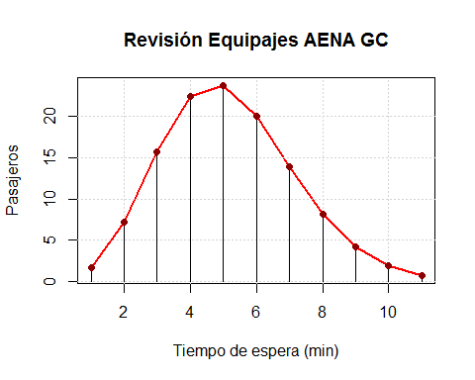

Conclusiones